PEER FEEDBACK

For each of your questions:

- Screenshot / copy feedback your
- Discuss the feedback, do you agree with it?
- Show / discuss any improvements you have made.

- Extension: Overall evaluate your site feedback… Was it useful, did you get enough responses, did you ask the right questions?

WEBSITE TESTING

BEST PRACTICE
Test | Results | Comment / improvement
Does your sites logo link to your homepage? | Yes, it does. The logo links back to the home page. Also, if you log-in to the dashboards and go into each site once you click the logo it takes you back to the main dashboard.
Have you commented all of your CSS? | Yes, I commented in all my CSS files | 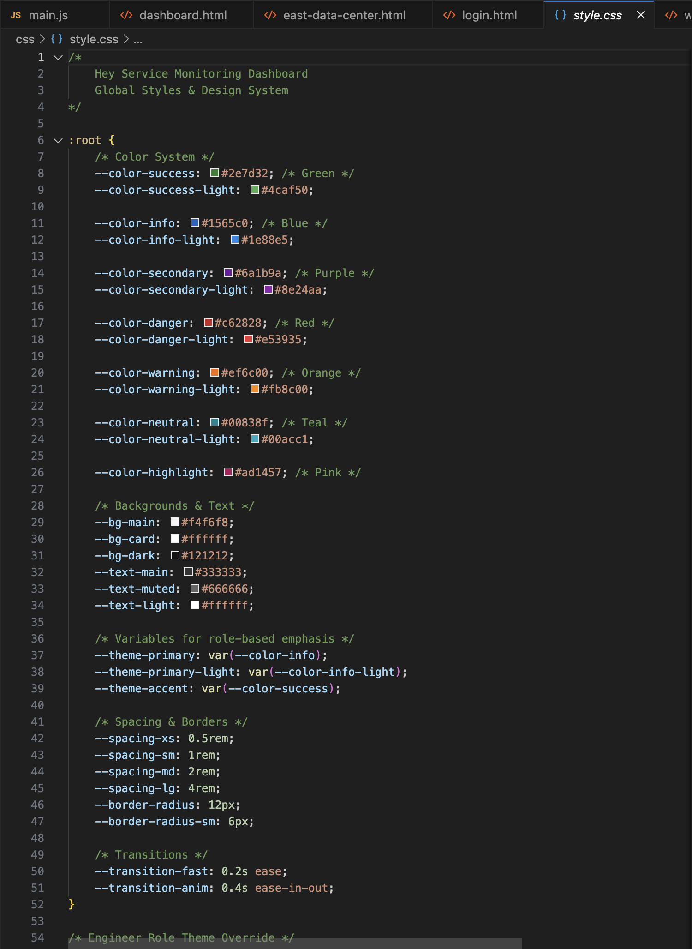
Have you commented all of your HTML? | Yes, I commented on all my HTML files. | 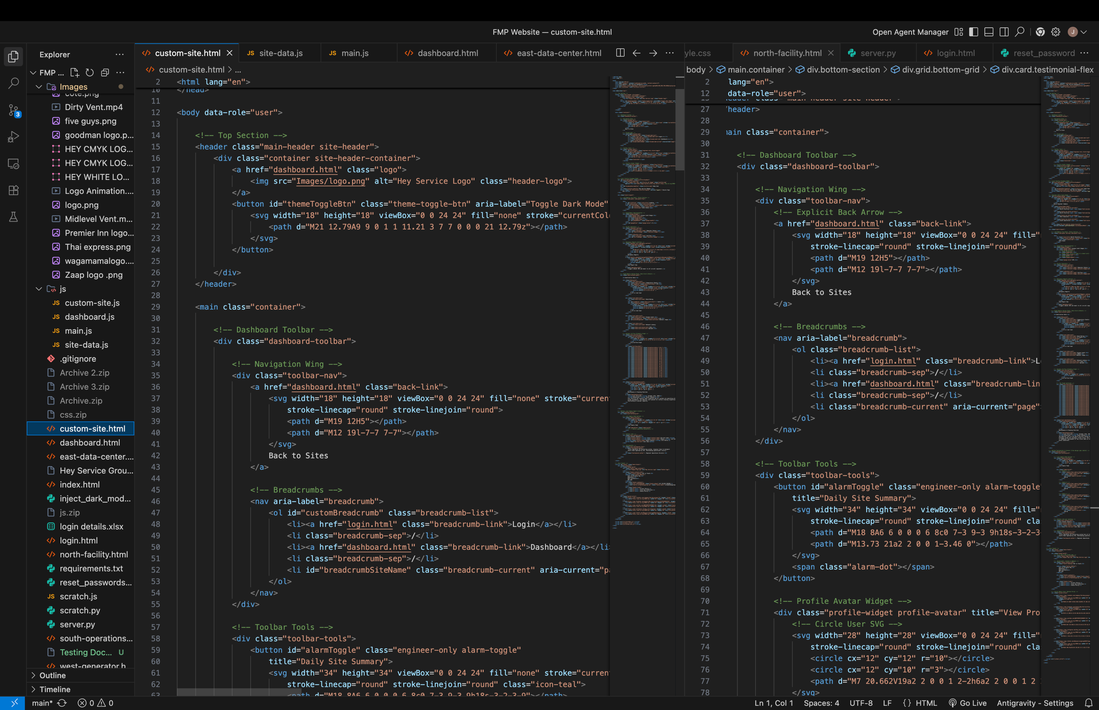
Are all your files named correctly? | Yes, all my files has been named with the appropriate names. | 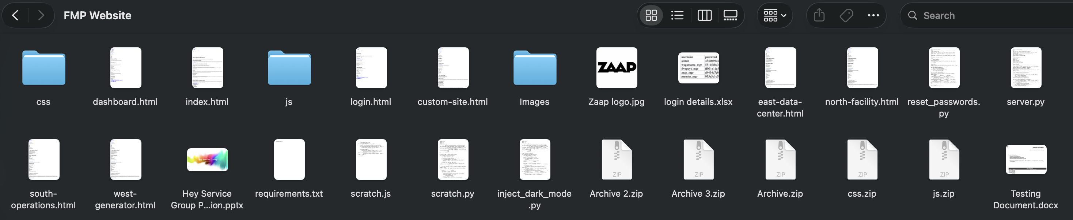
Have you used folders to organise your images and other files? | Yes, I have. | 
Do your folders still have any files related to the old version of the website? | No everything in the files are what are needed for the websites.
Have you named your CCS classes in easy to understand names? | Yes my CSS classes and id’s are simple and easy to understand. | 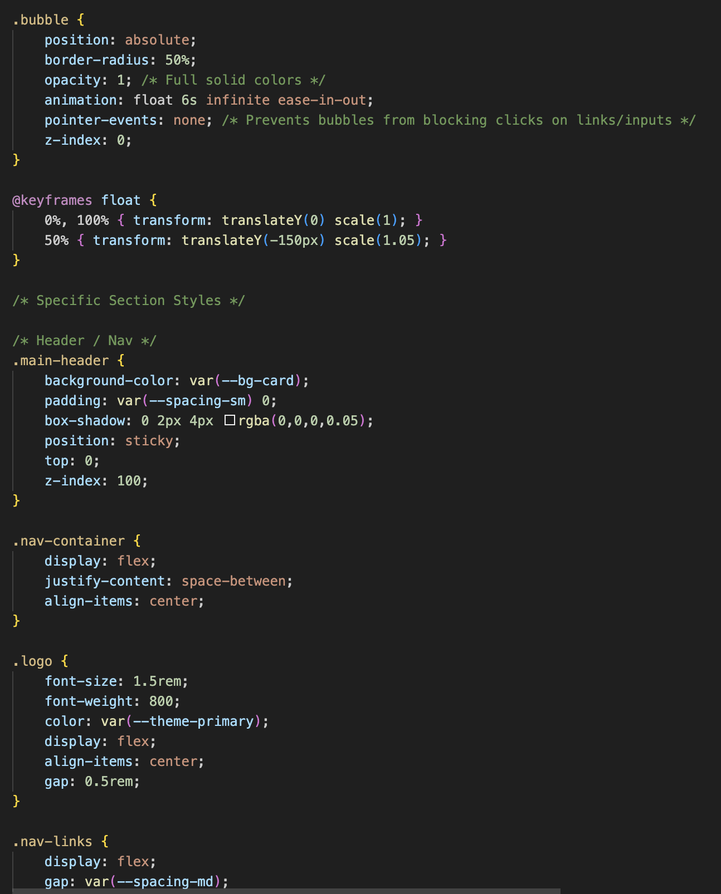

LINKS AND FUNCTIONALITY
Test | Results | Screenshot of improvement if applicable
All links (https://heyservicegroup.netlify.app/) | It works properly and it send you to the home page.
All links (https://heyservicegroup.netlify.app/login) | It works perfectly.
All links (https://heyservicegroup.netlify.app/dashboard.html) | It works properly.
All links ()
All links ()
All links ()
Navigation hover and animation

BROWSER TESTING
Browser | Screenshot of website on browser | Comment / improvement
Google Chrome
Edge
Firefox
Internet Explorer

Test | Results / Screenshots | Comment / Improvement
Does your website display correctly on a mobile? (Use inspect mobile in Edge) – If this doesn’t work screenshot parts that don’t display correctly.
Think about flex, max-width 100% and CSS @media Rules.

Does your site horizontally scroll? (We don’t want this) on mobile
Does any of your content squash instead of stack?
Do any of your images go off screen or appear squashed?

TAGS
Browser | Results | Comment / improvement
Appropriate title tag on home page
Appropriate title tag on *page name*
Appropriate title tag on *page name*
Appropriate title tag on *page name*
Appropriate title tag on *page name*
Only one H1 used per page (for main heading?)
H2 / H3 / H4 used appropriately?

Display / Consistency
Test | Results | Comment / improvement
Do all your pages have the same layout?
Do all your footers look the same?
Do all your headers / navigation look the same?
Do you consistently use the same fonts for text / headings?
Are any images squashed?
Are any images poor quality / blurry?
Are any of your text areas too hard to read due to size / colour contrast or font choice?
Text / background contrast
https://webaim.org/resources/contrastchecker/
https://colourcontrast.cc/
Colour blind test: https://www.color-blindness.com/coblis-color-blindness-simulator/

